from sklearn import svm, datasets
iris = datasets.load_iris()
import pandas as pd
df = pd.DataFrame(iris.data,columns=iris.feature_names)
df['flower'] = iris.target
df['flower'] = df['flower'].apply(lambda x: iris.target_names[x])

from sklearn.model_selection import train_test_split
X_train, X_test, y_train, y_test = train_test_split(iris.data, iris.target, test_size=0.3)

model = svm.SVC(kernel='rbf',C=30,gamma='auto')
model.fit(X_train,y_train)
model.score(X_test, y_test)

BUSCAR OPTIMOS HYPER PARAMETERS
# RandomizedSearchCV posiblemente no da el mejor pero se le acerca
Cuando hay mucha data, porque es rapido
# GridSearchCV, toma tiempo pero hace todas las combinaciones
Cuando se tiene poca data, porque toma mucho tiempo

from sklearn import svm
from sklearn.ensemble import RandomForestClassifier
from sklearn.linear_model import LogisticRegression
from sklearn.naive_bayes import GaussianNB
from sklearn.naive_bayes import MultinomialNB
from sklearn.tree import DecisionTreeClassifier

# RandomizedSearchCV
from sklearn.model_selection import RandomizedSearchCV
rs = RandomizedSearchCV(svm.SVC(gamma='auto'), {
'C': [1,10,20],
'kernel': ['rbf','linear']
},
cv=5,
return_train_score=False,
n_iter=2
)

rs.fit(iris.data, iris.target)
pd.DataFrame(rs.cv_results_)[['param_C','param_kernel','mean_test_score']]

# RandomizedSearchCV
from sklearn.model_selection import RandomizedSearchCV
rs = RandomizedSearchCV(svm.SVC(gamma='auto'), {
'C': [1,10,20],
'kernel': ['rbf','linear']
},
cv=5,
return_train_score=False,
n_iter=2
)

rs.fit(iris.data, iris.target)
pd.DataFrame(rs.cv_results_)[['param_C','param_kernel','mean_test_score']]

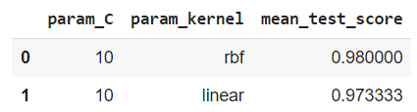

# GridSearchCV

from sklearn.model_selection import GridSearchCV

model_params = {
'svm': {
'model': svm.SVC(gamma='auto'),
'params' : {
'C': [1,10,20],
'kernel': ['rbf','linear']
}
},
'random_forest': {
'model': RandomForestClassifier(),
'params' : {
'n_estimators': [1,5,10]
}
},

'decision_tree': {
'model': DecisionTreeClassifier(),
'params': {
'criterion': ['gini','entropy'],

}
},

'naive_bayes_gaussian': {
'model': GaussianNB(),
'params': {}
},
'naive_bayes_multinomial': {
'model': MultinomialNB(),
'params': {}
},

'logistic_regression' : {
'model': LogisticRegression(solver='liblinear',multi_class='auto'),
'params': {
'C': [1,5,10]
}
}
}

scores = []

for model_name, mp in model_params.items():
clf = GridSearchCV(mp['model'], mp['params'], cv=5, return_train_score=False)
clf.fit(iris.data, iris.target)
scores.append({
'model': model_name,
'best_score': clf.best_score_,
'best_params': clf.best_params_
})

df = pd.DataFrame(scores,columns=['model','best_score','best_params'])
df

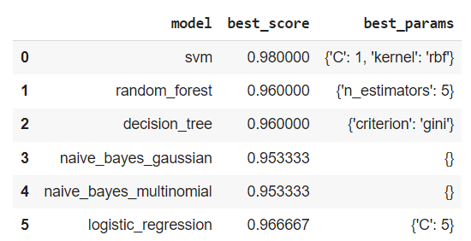
Best Option SVM with 98% using C:1 and kernel:’rbf’

from sklearn.ensemble import BaggingClassifier

bag_model = BaggingClassifier(
base_estimator=DecisionTreeClassifier(),
n_estimators=100,
max_samples=0.8,
oob_score=True,
random_state=0
)
bag_model.fit(X_train, y_train)
bag_model.oob_score_

0.95

